

American International University-Bangladesh (AIUB)
Department of Computer Science
Faculty of Science & Technology (FST)

PROJECT TITLE : Vehicle Rental Management System

Semester: Spring 25-26

Group: 07 |  | Section: P
SL | Student Name | Student ID
1 | MD Shahriar Hossain | 23-54028-3
2 | Eashita Pramanik | 23-54464-3
3 | Rifah Tasnia Richi | 23-51117-1
4 | Shabiha Sultana | 23-54476-3
5 | S. M Inthakab Kabir | 23-51534-3

Table of Contents

1. Project Proposal xx
1.1 Background to the Problem xx
1.2 Selection of Process Model xx
2. Timeline Chart / Gantt Chart ………………………….………………………………………………………………...xx
3. PRD xx
3.1 Functional Requirements xx
3.2 Non-Functional Requirements xx
4. Software Design xx
4.1 System Deisgn xx
4.2 UI Deisgn using Figma xx
5. Git Workflow xx
6. Software Testing xx
7. Conclusion xx

1. PROJECT PROPOSAL

1.1Background to the Problem

The Vehicle Rental Management System (VRMS) is designed to address the inefficiencies and challenges commonly faced in vehicle rental businesses and fleet management operations. In traditional rental operations, managing vehicle availability, customer bookings, driver assignments, payment processing, and compliance records is often time-consuming, error-prone, and heavily dependent on manual work. Our project automates these processes, providing a centralized and structured system where vehicle information, booking histories, payment records, and rental transactions are securely stored and easily accessible. It eliminates data redundancy, reduces human errors, and streamlines communication between all operational departments. By integrating role-based access, the system ensures that sensitive information is handled securely while allowing staff to perform their tasks efficiently. Overall, this project improves fleet management, enhances customer experience, saves time for rental staff, and ensures accuracy in bookings and billing, making it a vital tool for modern vehicle rental administration.
The application supports multiple user roles, each with different access permissions and responsibilities:
1.Admin
2.Manager
3.Customer
4.Driver
Each user can log in with their own credentials and access features according to their role. Common features like user authentication, profile management, and role-based dashboards are available to ensure smooth operation and secure data handling. The system provides centralized control for the administrator while maintaining flexibility and usability for other staff and customers.

The target group of users of this project:
Admin
The admin is the primary controller of the system. They manage all types of users, oversee vehicle records, monitor all bookings and transactions, handle KYC approvals, configure role-based access control, and generate operational reports. Their role ensures complete system supervision and smooth rental operations.
Manager
Managers use the system to monitor and manage daily rental activities. They handle vehicle listings, approve or reject customer bookings, manage deposit and withdrawal requests, log vehicle maintenance records, and track insurance and license expiry dates to support decision-making and maintain operational efficiency.
Customer
Customers use the system to search and browse available vehicles, create bookings by selecting pickup dates and locations, and make secure payments through their preferred payment method. They can view their rental history, download invoices, manage their wallet, and submit reviews for completed rentals.
Driver
Drivers use the system to manage vehicle pickup and return operations. They confirm vehicle pickups, which updates the rental status in real time, record any damages observed at the point of return, and confirm returns to close the rental record. Their access is focused on active rental tracking to ensure accurate and timely field operations.Sonnet 4.6
  - Selection of Process Model
Agile Process Model Used: Scrum
Overview of the Scrum Process Model
Scrum is an Agile software development framework that emphasizes iterative development, continuous feedback, and incremental delivery of software. Instead of developing the entire system in a single cycle, Scrum divides the project into small, manageable iterations known as sprints, typically lasting two to four weeks. Each sprint results in a fully functional and testable increment of the system.
In the context of the Vehicle Rental Management System, all system requirements — such as vehicle management, booking and rental operations, payment processing, wallet management, KYC verification, driver tracking, notifications, and operational reports — are first collected and stored in a Product Backlog. During Sprint Planning, the most important and high-priority features are selected for development in the upcoming sprint. The development team then designs, codes, and tests these features within the sprint duration. At the end of each sprint, a Sprint Review is conducted to evaluate the developed functionality, followed by a Sprint Retrospective to identify improvements for the next sprint. This cycle continues until the system is fully developed across all three phases.
This iterative approach ensures that the Vehicle Rental Management System evolves progressively, with continuous refinement and validation at every stage of development.
Justification for Choosing Scrum for the Vehicle Rental Management System
The Scrum model was chosen for this project due to its strong alignment with the complex, dynamic, and evolving nature of vehicle rental operations. The following points provide a detailed and evidence-based justification for selecting Scrum as the most suitable Agile model:
1. Adaptability to Changing Requirements
Vehicle rental businesses are dynamic environments where requirements may change frequently due to pricing policy updates, booking rule changes, compliance regulations, or new fleet additions. Scrum allows requirements to be modified, added, or reprioritized between sprints without affecting the overall system architecture. This flexibility makes Scrum highly suitable for a Vehicle Rental Management System, where new modules or enhancements may be required during development.
2. Modular and Incremental Development
The Vehicle Rental Management System consists of multiple independent modules such as user authentication, vehicle listing, booking management, payment processing, wallet operations, maintenance logging, and reporting. Scrum supports incremental development, enabling each module to be developed, tested, and delivered independently. This reduces system complexity and allows early deployment of critical functionalities such as authentication and role-based access before more complex features like payments and analytics are introduced.
3. Early and Continuous Feedback
Scrum encourages regular feedback through sprint reviews. This allows stakeholders — such as rental staff, managers, administrators, or academic supervisors — to evaluate the system at regular intervals. Early feedback ensures that the system meets real-world rental operational requirements, reducing the risk of misaligned features and improving overall system usability.
4. Risk Reduction
By delivering working software at the end of each sprint, Scrum significantly reduces project risk. Errors, design flaws, or performance issues are identified early, preventing large-scale failures near the end of the project. This is especially important for a rental management system where financial transactions, KYC documents, and vehicle compliance records demand high accuracy and reliability.
5. Prioritization of Critical Functionalities
Scrum allows features to be prioritized based on importance. In the Vehicle Rental Management System, essential modules such as user registration, role-based dashboards, vehicle management, and booking can be developed first, ensuring that core rental operations are functional even if additional features such as reports and maintenance logs are developed in later sprints.
6. Improved Software Quality
Continuous testing and review during each sprint lead to better code quality and fewer defects. Since the Vehicle Rental Management System handles sensitive financial data, personal user information, and real-time booking records, maintaining high software quality is essential. Scrum's iterative testing process ensures data accuracy, system stability, and reliability across all modules.
7. Efficient Team Collaboration
Scrum defines clear roles and promotes regular communication within the development team through daily standups and sprint ceremonies. This improves coordination among team members responsible for database design, backend business logic, and user interface development. Enhanced collaboration leads to faster issue resolution and smoother project execution across all three development phases.
8. Real-World Applicability
Scrum is widely used in real-world software development projects, including transportation, logistics, and rental management platforms. Using Scrum in this project provides practical experience with an industry-standard Agile methodology, increasing the project's relevance and professional value.

2. Timeline Chart / Gantt Chart

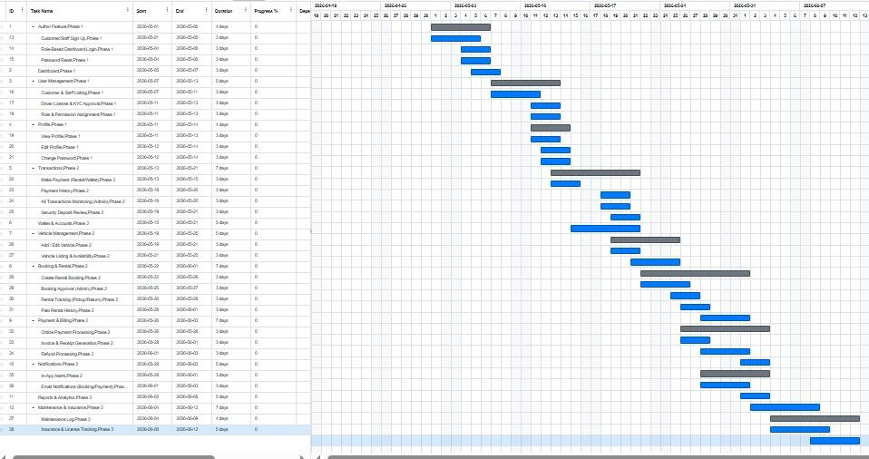

3. REQUIREMENTS DOCUMENT (PRD)
3.1 Scopes and Features
Feature 1 — Authentication
01. Sign Up [Customer] [Driver]
- Name, email, password, re-password, and user type fields must all be filled before submission.
- Email field must accept only a valid and unregistered email address, otherwise show "Email already used" message.
- Password must be minimum 8 characters long, otherwise show an invalid password message.
- Re-password must match the password field, otherwise show "Passwords do not match" message.
- User type must be selected, otherwise show "Please select a user type" message.
- On successful signup, credentials are stored in the database and the user is redirected to their role-based dashboard.
- A login confirmation email is sent to the registered email address.
02. Sign In [Admin] [Manager] [Customer] [Driver]
- Email and password must match a record in the database.
- On successful match, user is redirected to their role-based dashboard.
- On failure, user is prompted with "Email or password does not match" error message.
- Remember Me option persists the session across browser restarts.
- Clicking Forgot Password redirects the user to the password recovery page.
- Clicking Sign Up redirects the user to the registration page.
03. Reset Password [Admin] [Manager] [Customer] [Driver]
- Email must match a record in the database, otherwise show "No email found!" message.
- Pressing Send Code displays "Code sent!" message and sends the verification code to the user's email.
- New password must be at least 8 characters long and contain at least one special character.
- Re-type new password must match the new password field.
- Clicking Submit shows "Password changed" on success, or indicates what is wrong if any criteria are not met.
- Old password becomes invalid immediately after a successful reset.

Feature 2 — Dashboard
04. Role-Based Menu [Admin] [Manager] [Customer] [Driver]
- Menu is displayed only after successful authentication.
- Menu items shown depend on the logged-in user role.
- Clicking Dashboard opens the role-based dashboard page.
- Clicking Logout ends the active session and redirects the user to the sign in page.
- Role-restricted menu items are hidden from unauthorized roles.
- Active menu item is visually highlighted.
05. Dashboard Overview [Admin] [Manager] [Customer] [Driver]
- Dashboard loads immediately after successful sign in.
- Displays current available balance of the logged-in user.
- Shows recent transactions with type, amount, date and time, and status.
- Summary cards show total sent, total received, and pending transactions.
- Sensitive fields such as private key are masked by default.
- Dashboard data refreshes after each completed transaction.
- Quick actions are filtered by user role.

Feature 3 — Transactions
06.Send Money [Customer] [Manager]
- Amount must be numeric, greater than zero, and within the user's balance and transfer limit.
- Re-typed amount must exactly match the original amount.
- Private key signature must be validated before submission.
- Verification code must be correct before the transfer is processed.
- On success, balances are updated and a success message is shown.
- If validation fails, an error message is displayed and no transfer is made.
07. Receive Money / Transaction History [Customer] [Manager]
- Displays all incoming transactions for the logged-in user.
- Each record shows transaction ID, sender, amount, date and time, and status.
- User can filter by date range, status, or transaction type.
- User can search by transaction ID or sender name.
- Pagination is applied for large transaction lists.
- Transaction details can be viewed by clicking any record.
08. Transaction Monitoring [Admin] [Manager]
- Displays all platform transactions with ID, type, sender, receiver, amount, date, and status.
- Admin can filter by status — pending, completed, failed, or flagged — date range, or user.
- Admin can search by transaction ID, sender, or receiver.
- Admin can export the transaction list to CSV or PDF.
- Admin can click any transaction to view its full detail and audit trail.
09. Deposit / Withdrawal Review [Admin]
- Admin sees a list of all pending deposit and withdrawal requests.
- Each request shows user, amount, date, method, and current status.
- Admin can approve or reject each request.
- Rejection requires a reason to be entered.
- User is notified by email when their request is approved or rejected.
- Approved requests trigger balance updates immediately.

Feature 4 — Wallet & Accounts
10. Wallet Overview [Customer] [Manager]
- Displays account number, public key, wallet address, available balance, and pending balance.
- Private key is masked by default and revealed only after re-authentication.
- Copy button is available for public key and wallet address.
- Page is only accessible to the logged-in account owner or authorized admin.
- Balance shown reflects the most recent confirmed transactions.
Feature 5 — Vehicle Management
11. Add Vehicle [Admin] [Manager]
- All mandatory fields — name, plate number, type, and daily rate — must be filled before saving.
- Plate number must be unique in the system, otherwise show "Plate number already exists" message.
- Daily rate must be a positive numeric value.
- Photo upload accepts JPG, JPEG, and PNG formats only and validates file size.
- Vehicle status defaults to Available on creation.
- On success, vehicle appears in the vehicle listing immediately.
12. Vehicle Listing [Admin] [Manager] [Customer]
- All vehicles with status Available are listed by default.
- User can search by vehicle name, brand, or plate number.
- User can filter by type, price range, or availability status.
- Each card shows vehicle name, type, daily rate, and availability badge.
- Clicking View Detail opens the full vehicle detail page.
- Unavailable vehicles are shown with a disabled state.
Feature 6 — Booking & Rental
13. Create Booking [Customer]
- Customer must select a vehicle, pickup date, return date, and pickup location before submitting.
- Return date must be after the pickup date, otherwise show a validation error.
- Total cost is auto-calculated based on daily rate and number of rental days.
- Booking is only created if the selected vehicle is available for the chosen dates.
- On success, a booking confirmation message is shown and a confirmation email is sent to the customer.
- Vehicle availability is updated immediately after booking is created.
14. Booking Management [Admin] [Manager]
- All bookings are listed with customer name, vehicle, dates, total cost, and current status.
- Admin or manager can filter by status — pending, confirmed, cancelled, or completed.
- Clicking Approve changes the booking status to confirmed and notifies the customer by email.
- Clicking Reject requires a mandatory reason to be entered and notifies the customer by email.
- Clicking any booking opens the full booking detail view including payment status.
15. Rental Tracking [Admin] [Manager] [Driver]
- Dashboard shows all active rentals with vehicle, customer, driver, and current status.
- Driver can confirm vehicle pickup — rental status changes to In Use.
- Driver or manager can confirm vehicle return — rental status changes to Returned.
- Any damages noted at the time of return must be recorded before return can be confirmed.
- Rental record is closed after return is confirmed.
- Vehicle status is updated to Available automatically after return confirmation.
16. Rental History [Customer]
- Customer sees a list of all past and current rentals.
- Each record shows vehicle, dates, total cost, and status.
- Customer can click any record to view full rental details.
- Customer can download an invoice as PDF for completed rentals.
- Customer can submit a review for completed rentals.
Feature 7 — Payment & Billing
17. Payment Processing [Customer]
- Payment page shows full booking summary and total amount due.
- Customer can select payment method — card or wallet.
- Card details are validated for correct format and expiry date.
- Wallet payment checks available balance before processing.
- On success, payment status is updated and a receipt is generated.
- Failed payment shows a clear error message and allows the customer to retry.
18. Invoice & Receipt Management [Admin] [Manager] [Customer]
- Invoice is auto-generated after each successful payment.
- Invoice includes booking ID, customer, vehicle, dates, charges, and payment method.
- User can download the invoice as a PDF.
- Admin can search invoices by customer, booking ID, or date range.
- Invoices are read-only after generation and cannot be modified.
19. Refund Management [Admin]
- Admin sees all pending refund requests with customer name, booking details, and refund amount.
- Admin can approve or reject each refund request.
- Rejected requests require a documented reason to be entered.
- Approved refunds trigger a credit to the customer's wallet or original payment method.
- Customer is notified by email of the refund decision.
- Refund records are included in financial reports.
Feature 8 — User Management
20. User Listing [Admin]
- Admin sees all users with name, email, role, status, and registration date.
- Admin can search by name or email.
- Admin can filter by role or account status.
- Admin can activate or suspend any user account.
- Suspended users are blocked from signing in immediately.
- Clicking a user opens their full profile and activity log.
21. KYC / Registration Approval [Admin]
- Admin sees a queue of all pending registration applications.
- Admin can preview uploaded ID documents within the portal.
- Clicking Approve activates the account and sends an approval notification to the user.
- Clicking Reject requires a reason and sends a rejection notification to the user.
- All KYC review actions are logged with admin ID and timestamp.
- Rejected applicants can resubmit after correcting their documents.
22. Role & Access Control [Admin]
- Admin can view the full list of all roles — Admin, Manager, Customer, and Driver.
- Admin can configure which features each role can access through a permission matrix.
- Roles are assigned to users from the user detail page.
- Changes to role permissions take effect on the user's next login.
- Critical admin roles cannot be deleted or fully restricted.
- All role changes are recorded in the audit log.
Feature 9 — Profile
23. View Profile [Admin] [Manager] [Customer] [Driver]
- Profile page displays saved name, email, phone, date of birth, gender, and user type.
- No fields should display null or empty values.
- All fields on the view page are read-only.
- Edit button redirects the user to the Edit Profile page.
- Only the logged-in user or an authorized admin can view this page.
24. Edit Profile [Admin] [Manager] [Customer] [Driver]
- User can update name, phone number, date of birth, and gender.
- Email must be in correct format and must be unique in the system.
- Phone number must be in correct format — 11 digits.
- Required fields cannot be saved as blank, otherwise show a validation error.
- On clicking Save, the profile is updated in the database and a success message is shown.
25. Change Password [Admin] [Manager] [Customer] [Driver]
- Current password input must match the password stored in the database.
- New password must be minimum 8 characters long and contain at least one special character.
- Confirm new password must match the new password field.
- On clicking Save, the new password is stored and the old password is immediately invalidated.
- User receives an email notification confirming the password change.
- On success, show "Password changed successfully". On failure, show "Something went wrong".
Feature 10 — Reports & Analytics
26. Operational Reports [Admin] [Manager]
- Admin or manager can select report type — fleet utilization, revenue, bookings, or customer activity.
- Date range filter must be applied before generating the report.
- Report displays data in a table with summary totals and relevant charts.
- Report can be exported to CSV or PDF format.
- Reports reflect only confirmed and completed records.
Feature 11 — Notifications
27.In-App Notification Center [All Roles]
- Notification bell icon displays an unread count badge.
- Notifications are listed in reverse chronological order.
- Each notification shows a message, type, and timestamp.
- User can mark individual notifications as read or clear all at once.
- Notifications are generated for booking updates, payment events, and admin actions.
- Unread notifications persist until explicitly dismissed.
28. Email Notification System [All Roles]
- Email is sent on signup confirmation, booking approval or rejection, payment success, refund decision, and password change.
- Emails include relevant details such as booking ID, amount, or next steps.
- Emails are delivered within 2 minutes of the triggering event.
- Email templates are branded with the system logo and name.
- Users cannot disable critical security emails such as password change notifications.
Feature 12 — Maintenance & Insurance Records
29. Vehicle Maintenance Log [Admin] [Manager]
- Admin or manager selects a vehicle and records maintenance type, date, cost, notes, and service provider.
- Required fields are vehicle, maintenance type, and date — all must be filled before saving.
- Vehicle status is set to Under Maintenance during active service.
- Cost is recorded for financial reporting purposes.
- Maintenance records are read-only after saving to preserve history.
- Maintenance history is viewable per vehicle from the vehicle detail page.
30. Insurance & License Tracking [Admin] [Manager]
- Admin records insurance provider, policy number, and expiry date per vehicle.
- Admin records driver license number and expiry date per driver.
- System sends an alert notification 30 days before any document expires.
- Expired documents are flagged with a red badge in the listings.
- Records are editable to update renewed policies.
- All updates are logged in the audit trail.

3.2 Functional Requirements
Functional requirements define what the system must do. The Vehicle Rental Management System is designed to automate and manage core vehicle rental operations efficiently. The following functional requirements describe the system's expected behavior and features.
1. User Authentication and Authorization
- The system allows users to log in using valid email and password credentials.
- The system supports role-based access control for Admin, Manager, Customer, and Driver roles.
- The system restricts access to functionalities based on the logged-in user's role.
- The system allows administrators to create, update, activate, and suspend user accounts.
- The system sends a login confirmation email upon successful registration.
2. Role-Based Dashboard
- The system displays a role-specific dashboard immediately after successful login.
- The system shows relevant menu items based on the logged-in user's role.
- The system displays available balance, recent transactions, total sent, total received, and pending transactions on the dashboard.
- The system masks sensitive fields such as private keys by default on the dashboard.
- The system refreshes dashboard data automatically after each completed transaction.
3. Password Management
- The system allows users to reset their password using a verification code sent to their registered email.
- The system enforces a minimum password length of 8 characters with at least one special character.
- The system allows users to change their password from the profile section.
- The system invalidates the old password immediately after a successful password reset or change.
- The system sends an email notification to the user whenever their password is changed.
4. Wallet and Account Management
- The system displays the account number, public key, wallet address, available balance, and pending balance for each user.
- The system masks the private key by default and reveals it only after re-authentication.
- The system provides a copy button for the public key and wallet address.
- The system allows users to send money by entering an amount, confirming it, and signing with a private key.
- The system validates the private key signature and verification code before processing any transfer.
5. Transaction Management
- The system displays all incoming and outgoing transactions for the logged-in user.
- The system shows transaction ID, sender, receiver, amount, date and time, and status for each record.
- The system allows users to filter transactions by date range, status, or transaction type.
- The system allows users to search transactions by transaction ID or sender name.
- The system applies pagination for large transaction lists.
6. Transaction Monitoring
- The system allows admins and managers to monitor all platform transactions.
- The system allows filtering transactions by status — pending, completed, failed, or flagged — date range, or user.
- The system allows searching transactions by transaction ID, sender, or receiver name.
- The system allows exporting the full transaction list to CSV or PDF format.
- The system allows admins to click any transaction to view its full detail and audit trail.
7. Deposit and Withdrawal Review
- The system displays all pending deposit and withdrawal requests to the admin.
- The system shows the user, amount, date, payment method, and current status for each request.
- The system allows the admin to approve or reject each deposit or withdrawal request.
- The system requires a documented reason when rejecting any request.
- The system notifies the user by email immediately when their request is approved or rejected.
8. Vehicle Management
- The system allows admins and managers to add new vehicles with fields for name, type, plate number, brand, model, year, color, seating capacity, daily rate, status, and photo.
- The system enforces unique plate numbers and rejects duplicates with a clear error message.
- The system accepts vehicle photo uploads in JPG, JPEG, and PNG formats only.
- The system sets the vehicle status to Available by default upon creation.
- The system allows admins and managers to edit or delete existing vehicle records.
9. Vehicle Listing and Search
- The system lists all vehicles with Available status by default on the vehicle browsing page.
- The system allows users to search vehicles by name, brand, or plate number.
- The system allows users to filter vehicles by type, price range, or availability status.
- The system displays vehicle name, type, daily rate, and availability badge on each vehicle card.
- The system shows unavailable vehicles in a disabled state so customers can distinguish them clearly.
10. Booking Creation
- The system allows customers to create a booking by selecting a vehicle, pickup date, return date, and pickup location.
- The system validates that the return date is after the pickup date before allowing submission.
- The system auto-calculates the total rental cost based on the daily rate and number of rental days.
- The system creates a booking only if the selected vehicle is available for the chosen dates.
- The system sends a booking confirmation email to the customer upon successful booking creation.
11. Booking Management
- The system displays all bookings with customer name, vehicle, dates, total cost, and current status to admins and managers.
- The system allows filtering bookings by status — pending, confirmed, cancelled, or completed.
- The system allows admins and managers to approve a pending booking, which changes its status to confirmed.
- The system requires a mandatory reason when rejecting any booking.
- The system notifies the customer by email when their booking is approved or rejected.
12. Rental Tracking
- The system displays all active rentals with vehicle, customer, driver, and current status on the rental tracking dashboard.
- The system allows drivers to confirm vehicle pickup, which changes the rental status to In Use.
- The system allows drivers or managers to confirm vehicle return, which changes the rental status to Returned.
- The system requires any damages to be recorded before a vehicle return can be confirmed.
- The system automatically updates the vehicle status to Available after a return is confirmed.
13. Rental History
- The system displays a list of all past and current rentals for the logged-in customer.
- The system shows vehicle name, rental dates, total cost, and status for each rental record.
- The system allows customers to view the full detail of any rental record by clicking on it.
- The system allows customers to download an invoice as a PDF for any completed rental.
- The system allows customers to submit a review for any completed rental.
14. Payment Processing
- The system displays the full booking summary and total amount due on the payment page.
- The system allows customers to select a payment method — card or wallet.
- The system validates card details for correct format and expiry date before processing.
- The system checks the available wallet balance before processing a wallet payment.
- The system generates a receipt automatically upon successful payment.
15. Invoice and Receipt Management
- The system auto-generates an invoice after each successful payment.
- The system includes booking ID, customer name, vehicle details, rental dates, charges, and payment method in every invoice.
- The system allows users to download invoices as PDF files.
- The system allows admins to search invoices by customer name, booking ID, or date range.
- The system makes all invoices read-only after generation so they cannot be modified.
16. Refund Management
- The system displays all pending refund requests with customer name, booking details, and refund amount to the admin.
- The system allows admins to approve or reject each refund request.
- The system requires a documented reason when rejecting any refund request.
- The system credits the refund amount to the customer's wallet or original payment method upon approval.
- The system notifies the customer by email of the refund decision immediately after processing.
17. User Management
- The system displays all registered users with name, email, role, status, and registration date to the admin.
- The system allows admins to search users by name or email address.
- The system allows admins to filter users by role or account status.
- The system allows admins to activate or suspend any user account immediately.
- The system blocks suspended users from signing in as soon as the suspension is applied.
18. KYC and Registration Approval
- The system displays a queue of all pending registration applications to the admin.
- The system allows admins to preview uploaded ID documents within the portal before making a decision.
- The system activates the user account and sends an approval notification when the admin clicks Approve.
- The system requires a reason and sends a rejection notification when the admin clicks Reject.
- The system logs all KYC review actions with the admin ID and timestamp for audit purposes.
19. Role and Access Control
- The system allows admins to view all roles — Admin, Manager, Customer, and Driver.
- The system allows admins to configure which features each role can access through a permission matrix.
- The system applies role permission changes on the user's next login.
- The system prevents critical admin roles from being deleted or fully restricted.
- The system records all role and permission changes in the audit log.
20. Profile Management
- The system displays the user's name, email, phone, date of birth, gender, and user type on the profile page.
- The system makes all fields on the view profile page read-only.
- The system allows users to update their name, phone number, date of birth, and gender from the edit profile page.
- The system validates that the email is in the correct format and is unique in the system before saving.
- The system validates that the phone number is in the correct 11-digit format before saving.
21. Profile Photo Management
- The system displays the current profile image or a default image on the profile page.
- The system accepts only PNG and JPG formats for profile photo uploads.
- The system rejects any file format other than PNG and JPG with a clear error message.
- The system saves the new photo and redirects the user to the View Profile page upon confirmation.
22. Operational Reports
- The system allows admins and managers to select a report type — fleet utilization, revenue, bookings, or customer activity.
- The system applies a date range filter before generating any report.
- The system displays report data in a table with summary totals and relevant charts.
- The system allows exporting any report to CSV or PDF format.
- The system includes only confirmed and completed records in all generated reports.
23. In-App Notification Center
- The system displays a notification bell icon with an unread count badge for all users.
- The system lists notifications in reverse chronological order with message, type, and timestamp.
- The system allows users to mark individual notifications as read or clear all notifications at once.
- The system generates notifications for booking updates, payment events, and admin actions.
- The system persists unread notifications until they are explicitly dismissed by the user.
24. Email Notification System
- The system sends an email on signup confirmation, booking approval or rejection, payment success, refund decision, and password change.
- The system includes relevant details such as booking ID, amount, and next steps in every email.
- The system delivers all emails within 2 minutes of the triggering event.
- The system uses branded email templates with the system logo and name.
- The system prevents users from disabling critical security emails such as password change notifications.
25. Vehicle Maintenance Log
- The system allows admins and managers to log maintenance activities by selecting a vehicle and recording the maintenance type, date, cost, notes, and service provider.
- The system requires vehicle, maintenance type, and date as mandatory fields before saving.
- The system sets the vehicle status to Under Maintenance during active service.
- The system makes all maintenance records read-only after saving to preserve history.
- The system displays the full maintenance history per vehicle on the vehicle detail page.
26. Insurance and License Tracking
- The system allows admins to record insurance provider, policy number, and expiry date per vehicle.
- The system allows admins to record driver license number and expiry date per driver.
- The system sends an alert notification 30 days before any insurance or license document expires.
- The system flags expired documents with a red badge in the vehicle and driver listings.
- The system logs all insurance and license record updates in the audit trail.
27. Session Management
- The system automatically expires idle sessions after 30 minutes of inactivity.
- The system terminates all active sessions after a maximum duration of 8 hours.
- The system invalidates all session tokens and cookies immediately upon logout.
- The system sends a security notification when concurrent logins from more than 3 devices are detected.
- The system rotates session tokens after each privilege-level change or re-authentication event.
28. Audit Trail
- The system logs every login, logout, and failed login event with timestamp, IP address, and user agent.
- The system captures all admin actions — approvals, rejections, balance changes, and role updates — in an immutable audit trail.
- The system retains all audit logs for at least 12 months.
- The system prevents audit logs from being modified or deleted by any user including admins.
- The system fires automated alerts for anomalies such as multiple failed logins or unusual transaction volumes.
29. File Upload and Storage
- The system accepts only JPG, JPEG, PNG, and PDF file types for all uploads and rejects all other formats.
- The system rejects any file upload exceeding 5 MB before storage.
- The system scans all uploaded files for malware before storing or serving them.
- The system stores all uploaded files with randomized non-guessable filenames to prevent enumeration.
- The system controls file access through signed time-limited URLs so no files are accessible via direct public paths.
30. Search and Filter Operations
- The system allows searching across all major records — users, vehicles, bookings, and transactions — using primary search fields.
- The system returns full-text search results within 1.5 seconds for datasets of up to 100,000 records.
- The system executes all filter and sort operations server-side without loading the full dataset into memory.
- The system applies cursor-based or keyset pagination to maintain performance on large datasets.
- The system supports at least 5 simultaneous filter parameters in any search or filter combination.
3.3 Non-Functional Requirements
Non-functional requirements define how the system performs rather than what it does. These requirements ensure that the Vehicle Rental Management System is reliable, secure, efficient, and user-friendly.
1. Performance Requirements
- The system responds to all user actions within acceptable time — dashboard loads within 2 seconds, transactions respond within 3 seconds, and reports generate within 10 seconds.
- The system supports at least 500 concurrent users accessing the platform simultaneously without any performance degradation.
- The system efficiently handles large volumes of vehicle, booking, transaction, and user data without slowdown.
- The system returns search and filter results within 1.5 seconds for datasets of up to 100,000 records.
2. Security Requirements
- The system authenticates all users before granting access to any feature or page.
- The system enforces role-based access control on all server-side routes and returns HTTP 403 for unauthorized requests.
- The system stores all passwords as bcrypt hashes with a minimum cost factor of 12 and no plaintext storage is permitted.
- The system encrypts all private keys and sensitive tokens at rest using AES-256 encryption.
- The system uses HTTPS and TLS 1.2 or higher for all API communication.
3. Reliability Requirements
- The system operates continuously and remains available 99.5% of the time per calendar month.
- The system ensures data consistency even in the case of unexpected system crashes or failures.
- The system maintains accurate and error-free records across all financial transactions using ACID-compliant database operations.
- The system automatically triggers health monitoring alerts upon any service degradation.
4. Availability Requirements
- The system is available to all authorized users at any time with a minimum uptime of 99.5% per calendar month.
- The system ensures continuous availability of critical functions such as booking, payment, and vehicle management.
- The system supports quick recovery after failure with a Mean Time to Recovery not exceeding 1 hour.
- The system communicates all scheduled maintenance windows to users at least 24 hours in advance.
- The system maintains automatic failover for all critical database and server components.
5. Usability Requirements
- The system provides a simple, intuitive, and user-friendly interface that requires minimal training for all user roles.
- The system ensures all core workflows — booking, payment, and profile management — are completable in 5 steps or fewer.
- The system provides clear and specific error messages that identify the exact field or action causing the error.
- The system passes a WCAG 2.1 Level AA accessibility audit to support users with accessibility needs.
- The system provides a language toggle that switches the entire interface between English and Bengali instantly.
6. Scalability Requirements
- The system supports at least 10,000 concurrent registered users without performance degradation.
- The system allows horizontal scaling of the database and application servers without causing downtime.
- The system activates auto-scaling to handle traffic spikes of up to 300% of average load.
- The system allows file storage for documents and vehicle photos to scale independently of the application tier.
- The system supports future enhancements such as adding new modules or features with minimal structural changes.
7. Maintainability Requirements
- The system follows MVC or equivalent architecture with a clear separation of concerns across all modules.
- The system maintains unit test coverage of at least 80% for all business-critical modules.
- The system documents all API endpoints in an OpenAPI or Swagger specification that is kept up to date.
- The system supports CI/CD pipelines that enable zero-downtime deployments for all releases.
- The system structures all application logs in JSON format and centralizes them in a log management tool.
8. Portability Requirements
- The system runs correctly on all major operating systems including Windows, macOS, and Linux.
- The system is fully functional on the latest two versions of Chrome, Firefox, Edge, and Safari on desktop.
- The system renders and functions correctly on mobile devices with screen widths from 360px without requiring separate native apps.
- The system requires no third-party plugins or browser extensions to operate on any supported platform.
9. Data Integrity Requirements
- The system ensures accuracy and consistency of all data stored in the database at all times.
- The system uses database-level ACID transactions for all financial operations so that partial writes never occur.
- The system enforces data validation rules at both the front-end and back-end levels before any data is stored.
- The system prevents data duplication by enforcing unique constraints on critical fields such as email and plate number.
- The system rejects all invalid data formats — email, phone number, file types — with clear validation messages.
10. Backup and Recovery Requirements
- The system runs automated database backups daily and supports point-in-time recovery for the past 30 days.
- The system allows full data recovery in the event of system failure or data loss.
- The system tests backup restoration quarterly and verifies recovery integrity after each test.
- The system protects all backup data from unauthorized access using encryption and access controls.
- The system alerts the operations team within 15 minutes if any backup job fails.
11. Compliance Requirements
- The system complies with PDPA and GDPR-aligned data privacy and confidentiality principles.
- The system records explicit user consent to data collection during the registration process.
- The system fulfills user data deletion requests within the legally required timeframe.
- The system ensures sensitive data such as ID documents and payment details never appear in application logs.
- The system automatically purges inactive account data after 3 years as per the documented retention policy.
12. Session Management Requirements
- The system expires idle sessions automatically after 30 minutes of inactivity.
- The system terminates all active sessions after a maximum absolute duration of 8 hours.
- The system invalidates all session tokens server-side immediately upon logout or session expiry.
- The system sends a security notification when concurrent logins from more than 3 devices are detected for a single account.
- The system rotates session tokens after every privilege-level change or re-authentication event.
13. API Rate Limiting Requirements
- The system limits public endpoints such as login and signup to 10 requests per minute per IP address.
- The system limits authenticated API endpoints to 200 requests per minute per user token.
- The system returns an HTTP 429 response with a Retry-After header for all requests that exceed the rate limit.
- The system detects and blocks automated bots through CAPTCHA or behavioral analysis mechanisms.
- The system allows rate limit thresholds to be configured per endpoint without requiring a redeployment.
14. Disaster Recovery Requirements
- The system maintains a Recovery Point Objective of 4 hours or less so that data loss never exceeds this window.
- The system maintains a Recovery Time Objective of 2 hours or less so that full restoration is completed within this window.
- The system keeps a warm or hot standby environment running for all critical services at all times.
- The system conducts disaster recovery drills at least twice per year and documents all outcomes.
- The system maintains a recovery runbook accessible to the operations team at all times.
15. Error Handling Requirements
- The system catches all unhandled exceptions and displays them as friendly messages with no stack trace exposed to the user.
- The system returns structured JSON responses with a consistent error code, message, and HTTP status for all API errors.
- The system ensures non-critical failures such as email delivery do not prevent the completion of primary workflows.
- The system applies circuit breaker patterns to all external service integrations including payment gateways and email providers.
- The system continues operating in read-only mode for non-financial features during any database write outage.
16. File Upload and Storage Security Requirements
- The system accepts only JPG, JPEG, PNG, and PDF file types and rejects all others with a clear error message.
- The system rejects any file exceeding 5 MB in size before it reaches storage.
- The system scans all uploaded files for malware before storing or serving them to any user.
- The system stores all files with randomized non-guessable filenames to prevent enumeration attacks.
- The system controls all file access through signed time-limited URLs with no direct public path access permitted.
17. Notification Reliability Requirements
- The system delivers all email notifications within 2 minutes of the triggering event under normal load.
- The system retries failed email deliveries up to 3 times with exponential backoff before marking them as failed.
- The system persists all in-app notifications in the database so they are visible even if the user was offline at the time of creation.
- The system provides admins with a delivery status dashboard showing all failed notification jobs.
- The system ensures notification delivery failures never block or roll back any primary business transaction.
18. Search and Query Performance Requirements
- The system indexes all searchable tables — users, vehicles, bookings, and transactions — on their primary search fields.
- The system returns full-text search results within 1.5 seconds for datasets of up to 100,000 records.
- The system executes all filter and sort operations server-side without loading the full dataset into memory.
- The system uses cursor-based or keyset pagination to maintain consistent performance on large datasets.
- The system supports at least 5 simultaneous filter parameters in any search or filter operation.
19. Third-Party Integration Requirements
- The system enforces a timeout of 10 seconds or less for all integrations with payment gateways, email services, and SMS providers.
- The system supports configurable fallback providers for email and SMS when the primary provider is unavailable.
- The system displays integration health checks on the system monitoring dashboard at all times.
- The system stores all third-party API credentials in a secrets management system and never in source code or environment files.
- The system logs all integration failures with full context — provider name, payload, and error code — for post-incident analysis.
20. Mobile Responsiveness and PWA Requirements
- The system renders all pages correctly on screen widths from 360px to 2560px without any horizontal scrolling.
- The system ensures all touch targets including buttons and links are at least 44×44px in size.
- The system achieves a Lighthouse mobile performance score of 80 or above.
- The system is installable as a Progressive Web App with a valid web app manifest and a registered service worker.
- The system ensures critical pages — dashboard, booking, and payment — function correctly in offline or low-connectivity mode using cached content.

4. SOFTWARE DESIGN
4.1 System Design: Draw the system design for your project using Draw.io / MS tools.
- Prepare a Use Case Diagram by first defining all users (actors) and their roles. Show each actor’s interactions with the system through use cases inside a system boundary. Include relationships like include or extend where needed.
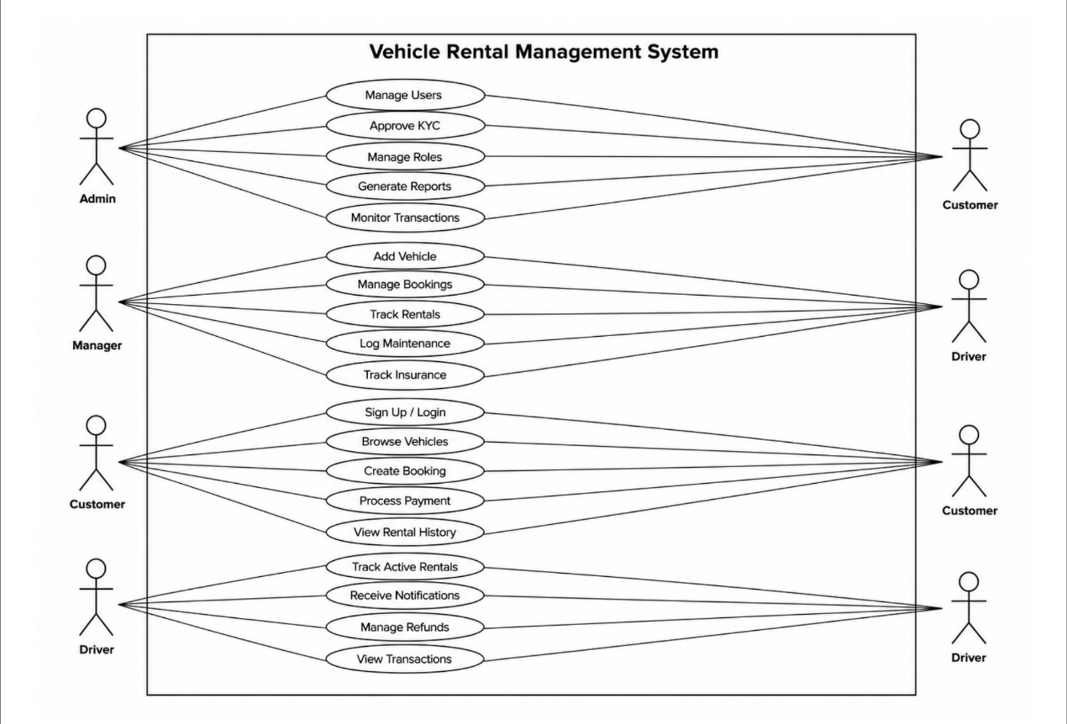

- Prepare a Class Diagram by identifying the main classes from your project. Add attributes and operations for each class, and show associations, generalizations, aggregations, or compositions between them.
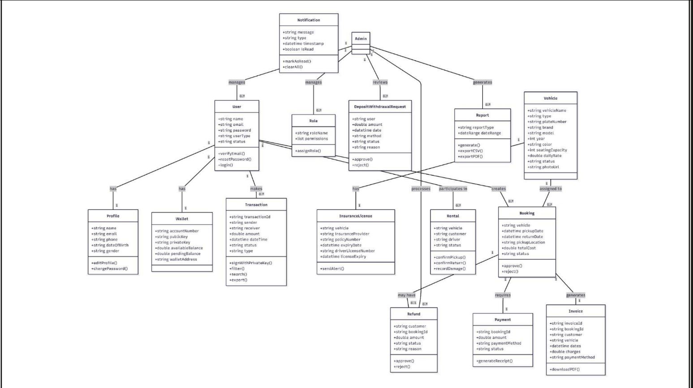

UI / Wireframe Design using Figma
- Build the wireframes directly from your SRS. Each functional requirement defined in the SRS should have a corresponding screen or component in the UI.
- Use the Trello user board (or equivalent task board) as a reference to decide which features and user flows need to be represented in the prototype.
- Create clickable wireframes that connect the main screens together, showing how a user will navigate through the system.
- Ensure the wireframe matches the actors, roles and functionalities described in the SRS and system design diagrams.
- Export the prototype and include screenshots or a link to your design as part of the report submission.

  - Sign Up
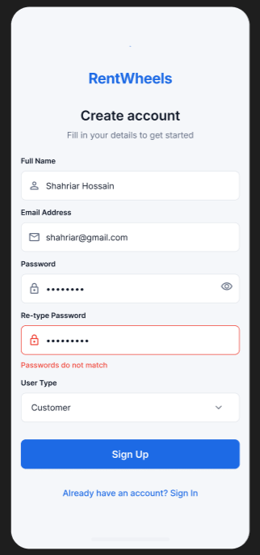

  - Sign In
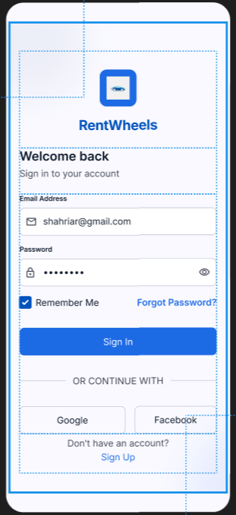
  - Reset Password
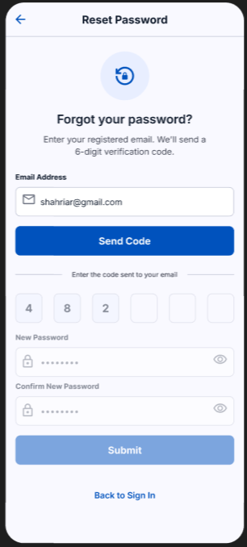
  - Financial Request
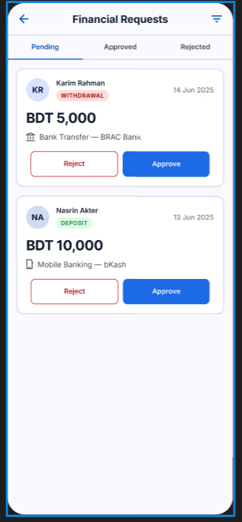
  - Add Vehicle
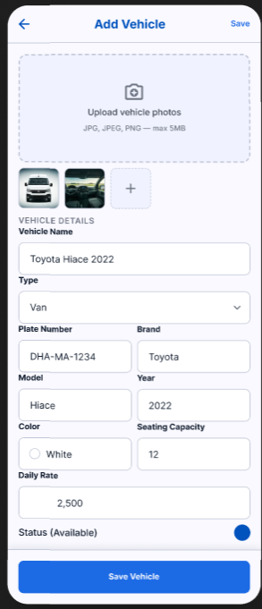
  - Homepage
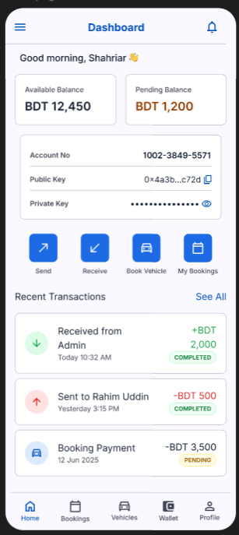
  - My Wallet
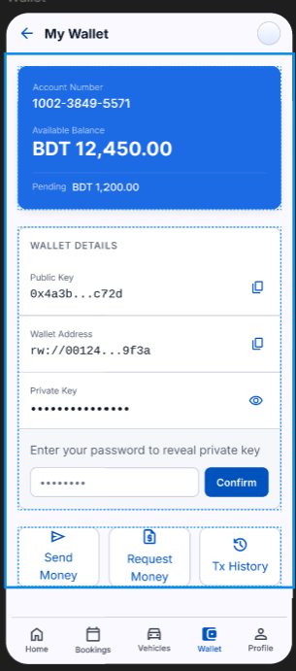
  - Profile
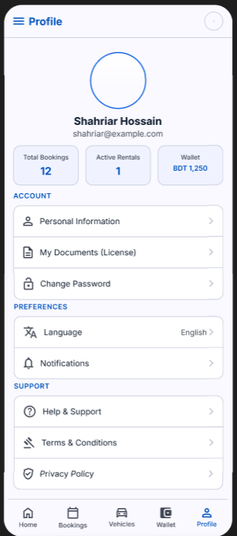
  - Vehicles
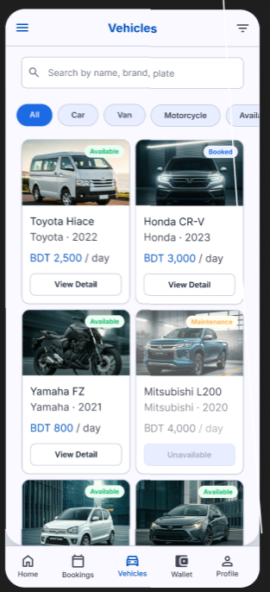
  - Book Vehicles
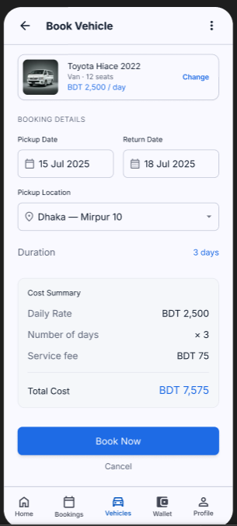
  - Tracking
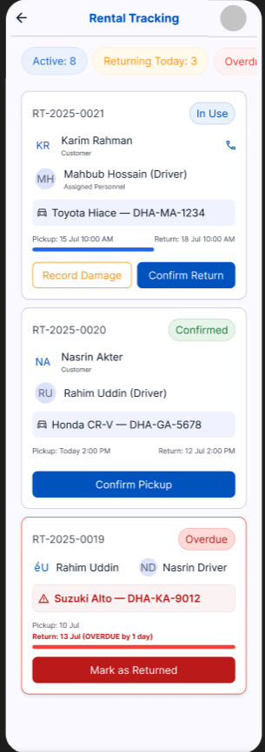
  - Booking Management
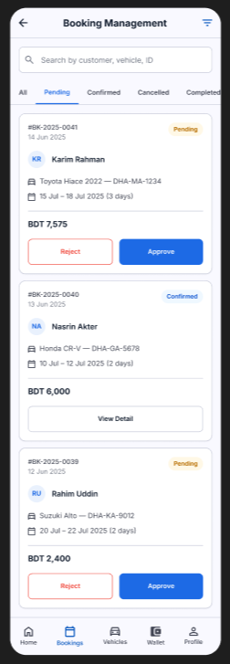

5. GIT WORKFLOW
- Create a central repository for the project on GitHub and set the master (or main) branch as the primary branch for integration.
- Each member should clone the repository and create their own feature branches for assigned tasks. Work on new features or fixes within these branches.
- Add files based on Trello cards, stage them and commit changes with clear messages that describe the purpose of each update. The text files (where the card serial, description are available based on Trello board) should be uploaded in the Git repository.
- Push commits from the feature branches to the remote repository so other members can see progress.
- Use pull to fetch and integrate changes from the remote repository into local copies, ensuring everyone stays updated.
- Merge feature branches into the master/main branch only after the work is tested and reviewed, resolving any conflicts that occur.
- Show evidence of collaboration by maintaining a clear commit history (using logs) with multiple commits, merges and contributions from all group members.
- Keep the repository organized with a clean history that tracks the project workflow from initialization to completion.
- Lastly, add the “Final Trello Board” screenshot in this section.

6. SOFTWARE TESTING

Project Name: Vehicle Rental Management System | Test Designed by: Rifah Tasnia
Test case ID:TC_FR_01 | Test Designed date:30/04/2026
Test Priority(Low,Medium,High): High | Test Execute by:
Module Name: User Authentication | Test Execution date:
Test Title: Verify User Signup Functionality

Description: Test that a new user can successfully create an account using valid signup details.

Precondition: User is on the Signup page.

Dependencies: None

Test Steps | Test Data | Expected Results | Actual Results | Status(Pass/Fail)
1. Navigate to Signup page  2. Fill all required fields  3. Click Signup button | Name: Rimpi Akter  Email: rimpi.test@example.com  Password: Test@1234  Re-password: Test@1234  User Type: Customer | User account is created successfully.  Success message is shown.  User is redirected to dashboard.  Confirmation email is sent.

Project Name: Vehicle Rental Management System | Test Designed by: Rifah Tasnia
Test case ID:TC_FR_02 | Test Designed date:30/04/2026
Test Priority(Low,Medium,High): High | Test Execute by:
Module Name: User Authentication | Test Execution date:
Test Title: Verify Role-based Login and Dashboard Redirection

Description: Test that a user can login with valid credentials and is redirected to the correct role-based dashboard.

Precondition: User account already exists and user is on the Signin page.

Dependencies: TC_FR_01

Test Steps | Test Data | Expected Results |  | Actual Results | Status(Pass/Fail)
1. Go to Signin page  2. Enter valid credentials  3. Click Signin | Email: admin@test.com  Password: Admin@123  Remember Me: Checked | User is successfully logged in and redirected to the respective role-based dashboard.
Project Name: Vehicle Rental Management System |  |  | Test Designed by: Rifah Tasnia
Test case ID:TC_FR_03 |  |  | Test Designed date:30/04/2026
Test Priority(Low,Medium,High): Medium |  |  | Test Execute by:
Module Name: Vehicle Search and Browsing |  |  | Test Execution date:
Test Title: Verify Vehicle Search and Filter Functionality
Description: Test that a user can search and filter available vehicles using valid criteria.
Precondition: User is logged in and the vehicle listing page is available.
Dependencies: TC_FR_02

Test Steps | Test Data | Expected Results | Actual Results | Status(Pass/Fail)
1. Navigate to Vehicle Listing page  2. Enter pickup 3. return dates  4. Select vehicle type 5.location  6. Click Search | Pickup Date: 10/05/2026  Return Date: 12/05/2026  Vehicle Type: Car  Location: Dhaka | Matching available vehicles are displayed.  Unavailable vehicles are not shown.  Vehicle name, price, availability status, and location are visible.

Project Name: Vehicle Rental Management System | Test Designed by: Rifah Tasnia
Test case ID:TC_FR_04 | Test Designed date:30/04/2026
Test Priority(Low,Medium,High): High | Test Execute by:
Module Name: Vehicle Booking | Test Execution date:
Test Title: Verify Vehicle Booking Functionality
Description: Test that a customer can book an available vehicle using valid booking information.
Precondition: User is logged in and at least one vehicle is available for the selected date range.
Dependencies: TC_FR_02, TC_FR_03

Test Steps | Test Data | Expected Results | Actual Results | Status(Pass/Fail)
1. Select an available vehicle  2. Click Book Now  3. Enter booking details  4. Confirm booking request | Vehicle: Toyota Corolla  Pickup Date: 10/05/2026  Return Date: 12/05/2026  Pickup Location: Dhaka  Customer Contact: 01700000000 | Booking request is created successfully.  Vehicle availability is updated.  Booking summary is displayed.  Booking status is shown as Pending or Confirmed.

Project Name: Vehicle Rental Management System | Test Designed by: Rifah Tasnia
Test case ID:TC_FR_05 | Test Designed date:30 /04/2026
Test Priority(Low,Medium,High): High | Test Execute by:
Module Name: Payment and Booking Confirmation | Test Execution date:
Test Title: Verify Payment and Booking Confirmation Functionality
Description: Test that a customer can complete payment and receive booking confirmation.
Precondition: User has an active booking request and is on the payment page.
Dependencies: TC_FR_04

Test Steps | Test Data | Expected Results | Actual Results | Status(Pass/Fail)
1. Open booking payment page  2. Select payment method  3. Enter valid payment details  4. Click Pay/Confirm Payment | Booking ID: BK-1001  Payment Method: Card  Card Number: 4111111111111111  Expiry Date: 12/28  CVV: 123 | Payment is processed successfully.  Booking status is updated to Confirmed.  Receipt or confirmation message is shown.  Confirmation notification is sent to the customer.

Project Name: Vehicle Rental Management System |  |  | Test Designed by: Eashita Pramanik
Test case ID:TC_07 |  |  | Test Designed date:28/04/2026
Test Priority(Low,Medium,High): High |  |  | Test Execute by:
Module Name: Transactions |  |  | Test Execution date:
Test Title: Verify Receive Money and Transaction History
Description: Test that incoming transactions are correctly displayed with filter and search options.
Precondition: User is logged in as Customer or Manager.
Dependencies: TC-06
Test Steps | Test Data | Expected Results |  | Actual Results | Status(Pass/Fail)
1. Login  2.go to Transaction History  3. search  4. Click on a transaction record | Search: Sender Name Filter: Status = Completed | Transaction list page opens  Relevant transactions displayed with ID, Sender, Amount, Date & Time, Status  Transaction details are shown correctly

Project Name: Vehicle Rental Management System | Test Designed by: Eashita Pramanik
Test case ID:TC_08 | Test Designed date:28/04/2026
Test Priority(Low,Medium,High): High | Test Execute by:
Module Name: Transactions | Test Execution date:
Test Title: Verify Platform Transaction Monitoring (Admin/Manager)

Description: Test that Admin or Manager can view, filter, search and export all platform transactions.
Precondition: User is logged in as Admin or Manager.
Dependencies: TC-02
Test Steps | Test Data | Expected Results |  | Actual Results | Status(Pass/Fail)
1. Login  2. to Transaction Monitoring  3. Click Export | Search: Transaction ID | All platform transactions list is displayed  Results filtered and searched correctly  Transaction list exported successfully to CSV or PDF

Project Name: Vehicle Rental Management System |  |  | Test Designed by: Eashita Pramanik
Test case ID:TC_09 |  |  | Test Designed date:28/04/2026
Test Priority(Low,Medium,High): High |  |  | Test Execute by:
Module Name: Transactions |  |  | Test Execution date:
Test Title: Verify Deposit and Withdrawal Request Review (Admin)
Description: Test that Admin can review, approve or reject deposit/withdrawal requests.
Precondition: User is logged in as Admin and pending requests exist.
Dependencies: None
Test Steps | Test Data | Expected Results |  | Actual Results | Status(Pass/Fail)
1. Login as Admin  2.go to Deposit/Withdraw  3. Select a request and click Approve  4.Select another request and Reject | Request ID: REQ_001 | List of pending requests displayed  Request approved, balance updated, user notified by email  Request rejected with reason, user notified

Project Name: Vehicle Rental Management System |  |  | Test Designed by: Eashita Pramanik
Test case ID:TC_10 |  |  | Test Designed date:28/04/2026
Test Priority(Low,Medium,High): High |  |  | Test Execute by:
Module Name: Wallet & Accounts |  |  | Test Execution date:
Test Title: Verify Wallet Overview
Description: Test that the logged-in user can view their wallet details including masked private key.
Precondition: User is logged in as Customer or Manager.
Dependencies: TC-02
Test Steps | Test Data | Expected Results |  | Actual Results | Status(Pass/Fail)
1. Login and navigate to Wallet section  2. View wallet information |  | Wallet page loads  Account Number, Public Key, Masked Private Key, Available Balance, Pending Balance and Copy buttons are displayed

Project Name: Vehicle Rental Management System
Test case ID:TC_11
Test Priority(Low,Medium,High): High
Module Name: Vehicle Management
Test Title: Verify Add New Vehicle Functionality
Description: Test that Admin or Manager can successfully add a new vehicle to the fleet with all required details.
Precondition: User is logged in as Admin or Manager.
Dependencies: TC-02

Test Steps | Test Data
1Login  2.Go to Add Vehicle page  3.Fill all vehicle details and upload photo  4. Click ave button | Vehicle Name: Toyota Camry Plate Number: DHK-A-5678  Brand: Toyota Model: Camry Year: 2024 Daily Rate: 3500  Photo: valid_image.jpg

Project Name: Vehicle Rental Management System
Test case ID:TC_12
Test Priority(Low,Medium,High): High
Module Name: Vehicle Management
Test Title: Verify Vehicle Listing with Search and Filter
Description: Test that users can browse available vehicles using search and filter options.
Precondition: User is logged in (any role) and vehicles exist in the system.
Dependencies: TC-11

Test Steps | Test Data | Expected Results
1. Navigate to Vehicle Listing page  2. Perform search and apply filters  3. Click View Detail button | Search: "Toyota" Filter: Type  = Sedan, Status = Available | List of available vehicles displayed as cards  Only matching vehicles shown with correct details and availability badge

Project Name:Vehicle Rental Management System | Test Designed by: Md. Shahriar Hossain
Test Case ID:TC_13 | Test Designed date:29.04.26
Test Priority(Low,Medium,High):HIgh | Test Executed by:
Module Name: Booking & Rental. | Test Execution date:
Test Title: Verify create booking functionality.
Description: Test customer booking with date validation and cost calculation.
Precondition: Customer logged in, vehicle available.
Dependencies: None.

Test Steps | Test Data | Expected Results | Actual Results | Status(pass/Fail)
- Select vehicle and dates  2. Click Book Now | Pickup: 2026-05-05 Return: 2026-05-10 | Total cost auto-calculated  Booking created, confirmation shown and emailed

Project Name:Vehicle Rental Management System | Test Designed by: Md. Shahriar Hossain
Test Case ID:TC_14 | Test Designed date:29.04.26
Test Priority(Low,Medium,High):High | Test Executed by:
Module Name: Booking & Rental. | Test Execution date:
Test Title: Verify booking management by admin/manager.
Description: Test approve/reject of customer bookings.
Precondition: Pending bookings exist.
Dependencies: None.

Test Steps | Test Data | Expected Results | Actual Results | Status(pass/Fail)
- 1. Go to Booking Management  - Approve or reject booking | Action: Approve | All bookings listed  Status updated, customer notified

Project Name:Vehicle Rental Management System | Test Designed by: Md. Shahriar Hossain
Test Case ID:TC_15 | Test Designed date:29.04.26
Test Priority(Low,Medium,High): High | Test Executed by:

Test Title: Verify rental tracking functionality.
Description: Test pickup and return confirmation.

Precondition: Active rental exists.
Dependencies: None.
Test Steps | Test Data | Expected Results |  | Actual Results | Status(pass/Fail)
- 1. Navigate to Rental Tracking  - 2. Confirm pickup or return | Action: Confirm Return | Active rentals displayed Status updated, vehicle marked Available

Project Name:Vehicle Rental Management System | Test Designed by: Md. Shahriar Hossain
Test Case ID:TC_16 | Test Designed date:29.04.26
Test Priority(Low,Medium,High):Medium | Test Executed by:
Module Name: Booking & Rental. | Test Execution date:
Test Title: Verify customer rental history and invoice download.
Description: Test viewing past rentals and downloading invoice.
Precondition: Customer has completed rentals.
Dependencies: None.

Test Steps | Test Data | Expected Results | Actual Results | Status(pass/Fail)
- Go to Rental History  - Download invoice for completed rental |  | Past bookings listed  PDF invoice downloaded successfully

Project Name:Vehicle Rental Management System |  |  | Test Designed by: Md. Shahriar Hossain
Test Case ID:TC_17 |  |  | Test Designed date:29.04.26
Test Priority(Low,Medium,High):High |  |  | Test Executed by:
Module Name: Payment & Billing. |  |  | Test Execution date:
Test Title: Verify payment processing for booking.
Description: Test payment using card or wallet.
Precondition: Booking created, customer logged in.
Dependencies: None.
Test Steps | Test Data | Expected Results |  | Actual Results | Status(pass/Fail)
- 1. Go to Payment page  - Select payment method and pay | Method: Wallet | Booking summary shown  Payment successful, receipt generated

Project Name:Vehicle Rental Management System |  |  | Test Designed by: Md. Shahriar Hossain
Test Case ID:TC_18 |  |  | Test Designed date:29.04.26
Test Priority(Low,Medium,High):Medium |  |  | Test Executed by:
Module Name: Payment & Billing. Verify invoice and receipt management. |  |  | Test Execution date:
Test Title: Test viewing and downloading invoices.
Description: Test viewing and downloading invoices.
Precondition: Completed payments exist.
Dependencies: None.
Test Steps | Test Data | Expected Results |  | Actual Results | Status(pass/Fail)
- Navigate to Invoices  - View detail and download PDF |  | Invoice list displayed  Invoice opens and PDF downloads

Project Name:Vehicle Rental Management System |  |  | Test Designed by:Shabiha Sultana
Test Case ID:TC_19 |  |  | Test Designed date:28.04.26
Test Priority(Low,Medium,High):Medium |  |  | Test Executed by:
Module Name: Payment & Billing |  |  | Test Execution date:
Test Title: Verify Refund Management by Admin
Description: Test processing refund requests
Precondition: Refund request submitted
Dependencies:
Test Steps | Test Data | Expected Results |  | Actual Results | Status(pass/Fail)
1.Go to Refund Management  2. Approve refund | Refund Request ID:REF-001 | Pending refunds listed  Refund processed, customer notified

Project Name:Vehicle Rental Management System | Test Designed by:Shabiha Sultana
Test Case ID:TC_20 | Test Designed date:28.04.26

Test Priority(Low,Medium,High):Medium |  |  | Test Executed by:
Module Name: User Management |  |  | Test Execution date:
Test Title: Verify User Listing and Management by Admin
Description: Test viewing, activating, and suspending users
Precondition: Admin logged in
Dependencies:
Test Steps | Test Data | Expected Results |  | Actual Results | Status(pass/Fail)
1.Go to User Listing  2.Suspend a user |  | All users displayed  User status changed to suspended

Project Name:Vehicle Rental Management System | Test Designed by:Shabiha Sultana
Test Case ID:TC_21 | Test Designed date:28.04.26
Test Priority(Low,Medium,High):Medium | Test Executed by:
Module Name: User Management | Test Execution date:
Test Title: Verify KYC / Registration Approval

Description: Test admin review and approval of pending registrations
Precondition: Pending KYC applications exist
Dependencies:
Test Steps | Test Data | Expected Results |  | Actual Results | Status(pass/Fail)
1.Go to KYC Approval queue  2. Approve or Reject application |  | Pending applications listed  Account activated/rejected, user notified

Project Name:Vehicle Rental Management System |  |  | Test Designed by:Shabiha Sultana
Test Case ID:TC_22 |  |  | Test Designed date:28.04.26
Test Priority(Low,Medium,High):Medium |  |  | Test Executed by:
Module Name: User Management |  |  | Test Execution date:
Test Title: Verify Role & Access Control
Description: Test assigning roles and permissions
Precondition: Admin logged in
Dependencies:
Test Steps | Test Data | Expected Results |  | Actual Results | Status(pass/Fail)
1.Go to Role Management  2. Assign role to user |  | Permission matrix shown  Permissions updated, effective on next login

Project Name:Vehicle Rental Management System |  |  | Test Designed by:Shabiha Sultana
Test Case ID:TC_23 |  |  | Test Designed date:28.04.26
Test Priority(Low,Medium,High):Medium |  |  | Test Executed by:
Module Name: Profile |  |  | Test Execution date:
Test Title: Verify View Profile
Description: Test viewing personal profile details
Precondition: User logged in
Dependencies:
Test Steps | Test Data | Expected Results |  | Actual Results | Status(pass/Fail)
1. Navigate to Profile |  | Profile details displayed (read-only)

Project Name:Vehicle Rental Management System |  |  | Test Designed by:Shabiha Sultana
Test Case ID:TC_24 |  |  | Test Designed date:28.04.26
Test Priority(Low,Medium,High):Medium |  |  | Test Executed by:
Module Name: Profile |  |  | Test Execution date:
Test Title: Verify Edit Profile
Description: Test updating profile information
Precondition: User logged in
Dependencies:
Test Steps | Test Data | Expected Results |  | Actual Results | Status(pass/Fail)
1.Click Edit Profile  2. Update fields and save |  | Editable form loads  Profile updated successfully

Project Name: Vehicle Rental Management System |  |  | Test Designed by: Eashita Pramanik
Test case ID:TC_37 |  |  | Test Designed date:28/04/2026
Test Priority(Low,Medium,High): High |  |  | Test Execute by:
Module Name: Data Integrity |  |  | Test Execution date:
Test Title: Verify Data Integrity and Backup
Description: Test that financial transactions maintain data integrity and backups are functional.
Precondition: Database backup and restore tools available.
Dependencies: None
Test Steps | Test Data | Expected Results |  | Actual Results | Status(Pass/Fail)
1. Perform a financial transaction  2. Perform backup and point-in-time restore |  | Transaction completed with ACID compliance  Restore successful with data integrity maintained

7. CONCLUSION
The Vehicle Rental Management System is a comprehensive and structured software solution designed to modernize and streamline the complete vehicle rental lifecycle. By automating core operations such as vehicle management, booking, payment processing, wallet transactions, driver tracking, KYC verification, and operational reporting, the system eliminates the inefficiencies and errors associated with traditional manual rental processes.The system's role-based architecture ensures that each user — Admin, Manager, Customer, and Driver — can access only the features relevant to their responsibilities, maintaining both security and operational clarity. With 30 functional requirements spanning 12 feature areas and 20 non-functional requirements covering performance, security, scalability, and compliance, the system is built to meet real-world operational demands at scale.The adoption of the Agile Scrum process model ensures that development remains flexible, iterative, and aligned with stakeholder expectations throughout all three project phases. Each sprint delivers a working increment, reducing risk and enabling continuous improvement.Overall, the Vehicle Rental Management System represents a reliable, secure, and scalable platform that addresses the genuine needs of modern rental businesses, enhances the customer experience, and empowers staff to perform their roles with greater efficiency and confidence.

Instructions:
- Minimum of 3 members and Maximum of 5 members per group.
- Font: Times New Roman ; Size: 12; Justify the para [Ctrl + J].
- Delete the highlighted part after completing this project report.
- The completed report should be within the range of 40 to 50 pages.

- Submission: Bring a hard copy of this report [per group] on the project evaluation day. Also, you will need to upload the soft copy later.

